ZOYASOFTS

INDUSTRY-READY INTERNSHIP PROGRAM
DATA ANALYTICS PROJECT REPORT

Project Title: Local Healthcare Accessibility Analysis

Submitted By: Sakshi Patil
Organization: Zoya Softs
Project Duration: 21 Days

Course: Bachelor of Computer Applications (BCA)

College Name: D. R. Mane Mahavidyalaya, Kagal

Tools Used: Excel/CSV, PostgreSQL, Python, Pandas, NumPy, Matplotlib, Microsoft Power BI

CHAPTER 1: INTRODUCTION

1.1 Introduction
Local Healthcare Accessibility Analysis is a data analytics project that studies publicly available information about hospitals, clinics, and diagnostic centers. The project organizes healthcare facility information and analyzes facility types, locations, specialties, public ratings, review counts, opening hours, consultation ranges, and emergency availability.
The project follows the data analytics lifecycle, including data collection, storage, preprocessing, SQL analysis, Python Exploratory Data Analysis (EDA), data visualization, dashboard development, and business recommendations.
The purpose is to understand the collected healthcare information and identify opportunities for better information management and digital healthcare services.

1.2 Problem Statement
Healthcare facility information may be available across different public sources and may be difficult to compare in one place. Users may need to check facility locations, specialties, opening hours, public ratings, consultation ranges, and emergency availability separately.
This project organizes the collected public information into a structured dataset and uses SQL, Python, and Power BI to analyze and present it.

1.3 Objectives
Collect publicly available healthcare facility information.
Store and organize the dataset.
clean and standardize the collected data.
Analyze healthcare facility distribution using PostgreSQL.
Perform exploratory data analysis using Python.
Create charts and visualizations.
Develop an interactive Power BI dashboard.
Identify patterns and limitations in the collected data.
Recommend practical digital solutions and further research opportunities for ZoyaSofts.

1.4 Scope of the Project
Included in the project
Hospitals, clinics, and diagnostic centers in the collected dataset.
Facility type, name, area, and specialty.
Public ratings and review counts.
Publicly listed opening hours and consultation ranges.
Publicly listed emergency availability.
SQL queries, Python analysis, charts, and Power BI dashboard.

1.5 Tools and Technologies
Tool/Technology | Purpose
Excel / CSV | Dataset organization and storage
PostgreSQL | Database management and SQL analysis
Python | Data analysis
Pandas | Data loading and manipulation
NumPy | Numerical operations
Matplotlib | Chart creation
Microsoft Power BI | Interactive dashboard
Python IDLE | Running Python scripts

1.6 Hardware Requirements
Desktop computer or laptop.
Keyboard and mouse.
Sufficient storage for the dataset, code, and outputs.
Internet connection for accessing public sources and downloading software, when required.

1.7 Software Requirements
Microsoft Windows or another compatible operating system.
Python with the required libraries.
PostgreSQL and a suitable SQL interface.
Microsoft Excel or a compatible spreadsheet application.
Microsoft Power BI Desktop.
A web browser for accessing public information.

CHAPTER 2: DATA COLLECTION

2.1 Data Source
Google Maps was used as a source for collecting publicly available information about healthcare facilities in Kolhapur. The collected information includes facility names, facility types, areas, specialities, opening hours, public ratings, review counts, publicly listed consultation ranges, and emergency availability.
The dataset contains 100 records and 10 columns. The collected data was organized in a CSV/Excel file and used for further analysis with PostgreSQL, Python, and Power BI.
Source Limitation: The dataset represents only the facilities collected for this project. It may not include every healthcare facility in the selected areas. Public information may change over time, and some details may be missing or require verification.
Data Source: Google Maps
URL: https://maps.google.com/

2.2 Data Collection Method
The healthcare dataset was collected and organized into a spreadsheet/CSV file. Each record represents a healthcare facility rather than an individual patient.
The collected information was organized into columns for facility type, facility name, area, specialty, opening hours, public rating, review count, consultation range, and emergency availability.
Only public facility information was included. Personal and confidential information was excluded.

2.3 Dataset Description
The dataset contains 100 collected healthcare facility records.
Facility Type | Number of Records
Hospital | 50
Clinic | 25
Diagnostic Center | 25
Total | 100

The dataset contains 10 columns, including a serial number and nine healthcare information fields.

2.4 Data Dictionary
Column | Meaning | Expected Data Type
Sr_no | Serial number of the record | Integer
Facility_Type | Hospital, Clinic, or Diagnostic Center | Categorical/Text
Facility_Name | Name of the healthcare facility | Text
Area | Area or locality of the facility | Text
Speciality | Listed medical specialty or service | Text
Opening_hours | Publicly listed operating hours | Text
Public_rating | Publicly listed rating | Decimal/Numeric
Review_count | Number of public reviews | Integer
Publicly_listed_consultation_range | Listed consultation fee range | Text or numeric range
Emergency_availability | Publicly listed emergency availability | Categorical/Text

2.5 Data Types
The dataset contains the following types of information:
Numerical: Sr_no, Public_rating, Review_count.
Categorical: Facility_Type and Emergency_availability.
Text: Facility_Name, Area, Speciality, and Opening_hours.
Range/Text: Publicly listed consultation range.
Opening hours and consultation ranges may need additional transformation if detailed numerical comparisons are required.

Out Put :--
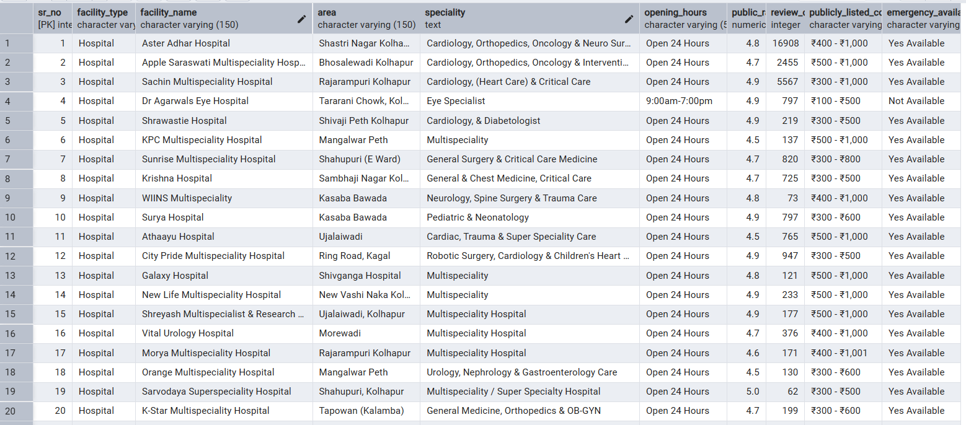

CHAPTER 3: DATA PREPROCESSING

3.1 Data Loading
The dataset was stored in CSV/spreadsheet format and used for SQL and Python analysis.
In Python, Pandas can be used to load the CSV file into a DataFrame. The dataset was checked to confirm the number of records and columns.
The collected dataset contains 100 records and 10 columns.
Screenshot 2: Insert the Python output showing successful dataset loading and dataset information.
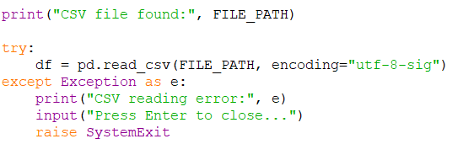

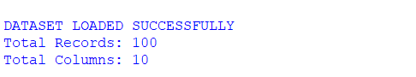

3.2 Data Cleaning
Data cleaning aims to improve consistency and prepare the dataset for analysis.
The cleaning process includes:
Checking column names.
Checking extra spaces in text fields.
Checking consistency in area names and facility types.
Identifying duplicate records.
Checking numerical columns such as ratings and review counts.
Checking missing information.
Preparing the cleaned dataset for analysis.
Only the cleaning operations actually performed should be reported as completed.
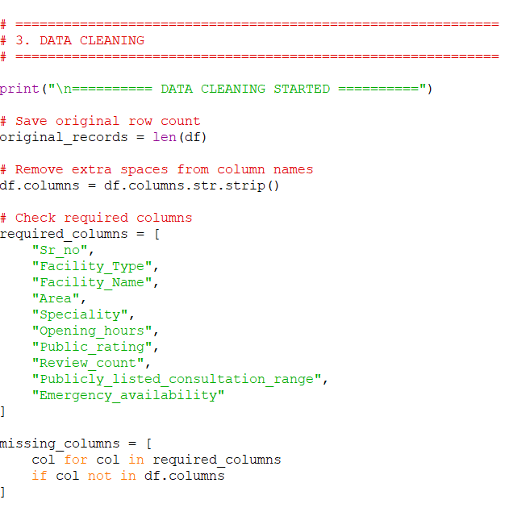
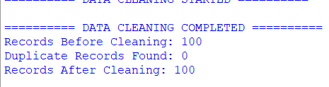

3.3 Missing Values
Some public listings may not provide every detail. Missing information should be identified and handled consistently.
Where appropriate, the value “Not Available” may be used for unavailable information. It must not be replaced with an invented rating, consultation fee, opening time, or emergency status.
For numerical analysis, text values such as “Not Available” should be converted to proper missing values where necessary.

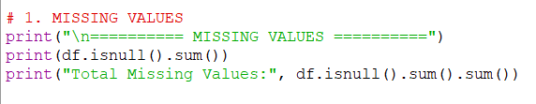

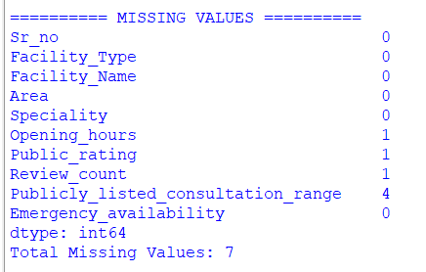

3.4 Duplicate Data
The dataset should be checked for duplicate records. Duplicate entries should be removed only after confirming that they represent the same facility record.
Facilities with similar names should not automatically be treated as duplicates because different branches may exist.
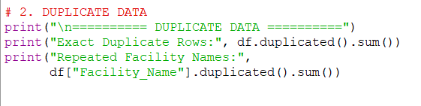

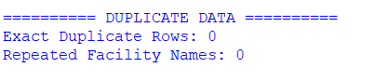

3.5 Outlier Handling
Ratings, review counts, and consultation ranges should be checked for unusual values.
For example, a rating outside the expected rating scale requires verification. Unusual values should not be removed automatically; the original public listing should be checked wherever possible.
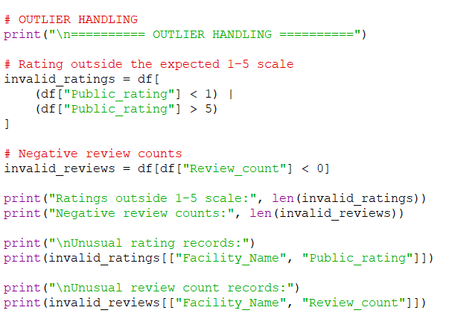
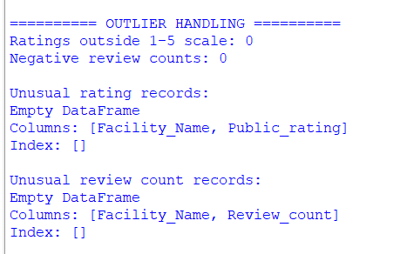

3.6 Data Transformation
Data transformation may include converting rating values into numeric format, review counts into integers, and standardizing text categories.
Consultation ranges and opening hours may remain text when the dataset does not contain enough structured information to convert them reliably.

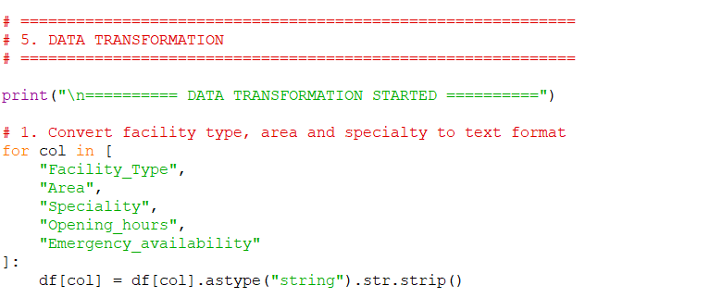
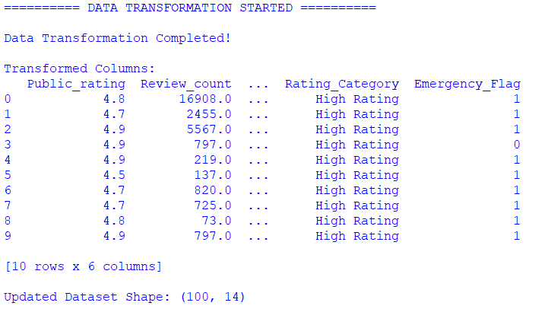

CHAPTER 4: EXPLORATORY DATA ANALYSIS (EDA)

4.1 Introduction to EDA
Exploratory Data Analysis is used to understand the dataset, identify patterns, and prepare useful information for visualization.
In this project, SQL and Python are used to examine healthcare facility counts, areas, public ratings, review counts, consultation ranges, and emergency availability.

4.2 Descriptive Statistics
Descriptive statistics summarize numerical data.
The project can examine:
- Average public rating.
- Median public rating.
- Standard deviation of public ratings.
- Total and distribution of review counts.
- Minimum and maximum values where valid.
These statistics should be calculated using valid numerical values only. The actual results should be added from the Python output or SQL results.

4.3 Univariate Analysis
Univariate analysis studies one variable at a time.
Examples include:
- Number of records by facility type.
- Number of facilities by area.
- Distribution of public ratings.
- Distribution of review counts.
- Distribution of emergency availability.

4.4 Bivariate Analysis
Bivariate analysis examines the relationship between two variables.
Examples include:
- Facility type versus number of facilities.
- Area versus facility count.
- Area versus average public rating.
- Facility name versus review count.
- Opening hours versus number of facilities, where the categories are standardized.

4.5 Correlation Analysis
Correlation analysis may be used to study relationships between numerical variables such as public rating and review count.
Correlation does not prove that one variable causes a change in another. Any result should be interpreted carefully, particularly when the dataset is limited.

4.6 Trend Analysis
The dataset does not contain a dedicated date or time-series column. Therefore, time-based trend analysis is not directly supported by the current dataset.
Future analysis could include trends if reliable, dated public information becomes available.

4.7 Key Findings
The dataset contains 100 records: 50 hospitals, 25 clinics, and 25 diagnostic centers.
Further findings should be taken from the actual SQL query results, Python charts, and Power BI dashboard. The collected records should not be treated as a complete count of all healthcare facilities in the region.
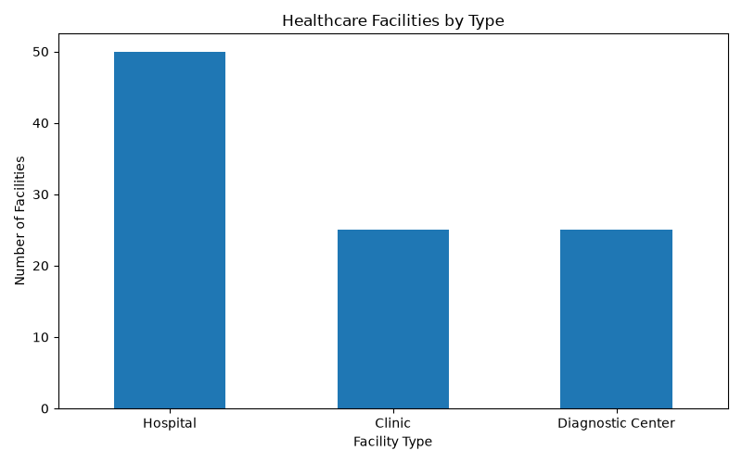

CHAPTER 5: DATA VISUALIZATION

5.1 Introduction
Data visualization presents analytical results in a clear graphical format. Python charts and a Power BI dashboard help users compare healthcare facility information.

5.2 Charts and Graphs
The charts created for this project may include:
- Facility Type-wise Count.
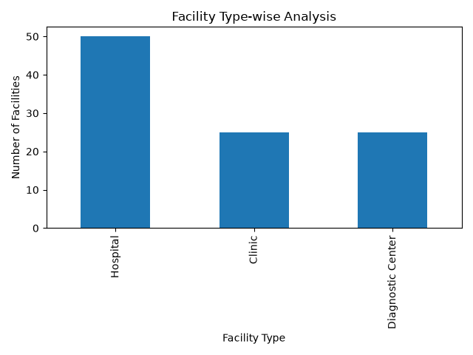

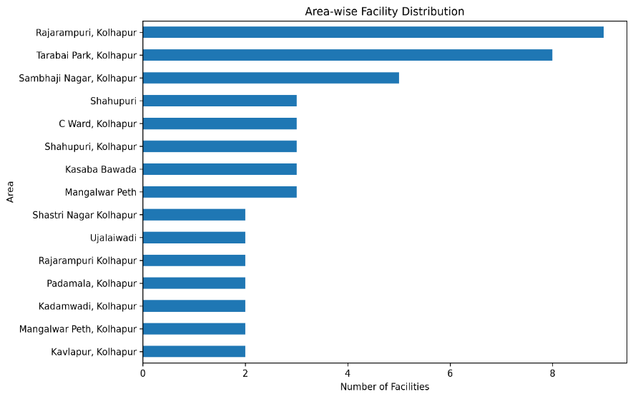
2.Area-wise Facility Distribution.
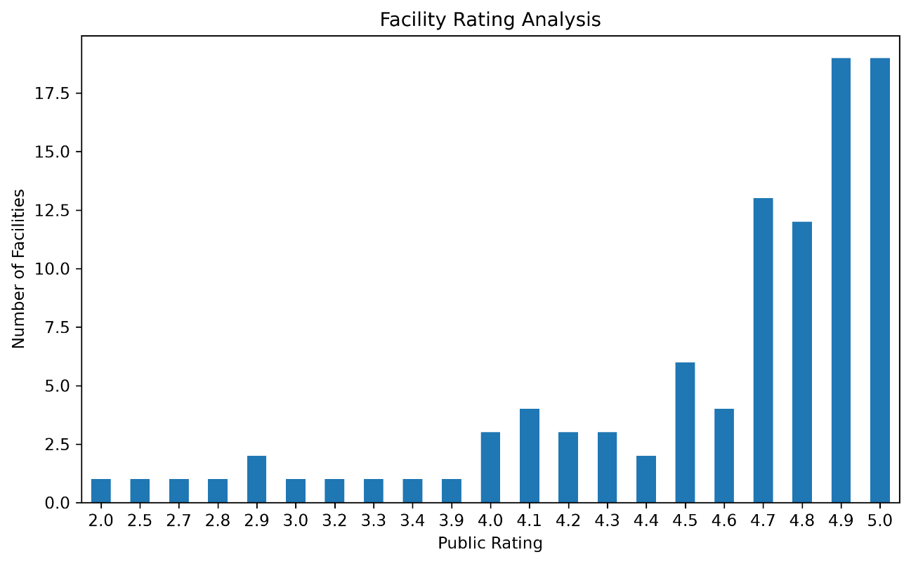
- Facility Rating Analysis.

- Review Count Analysis.
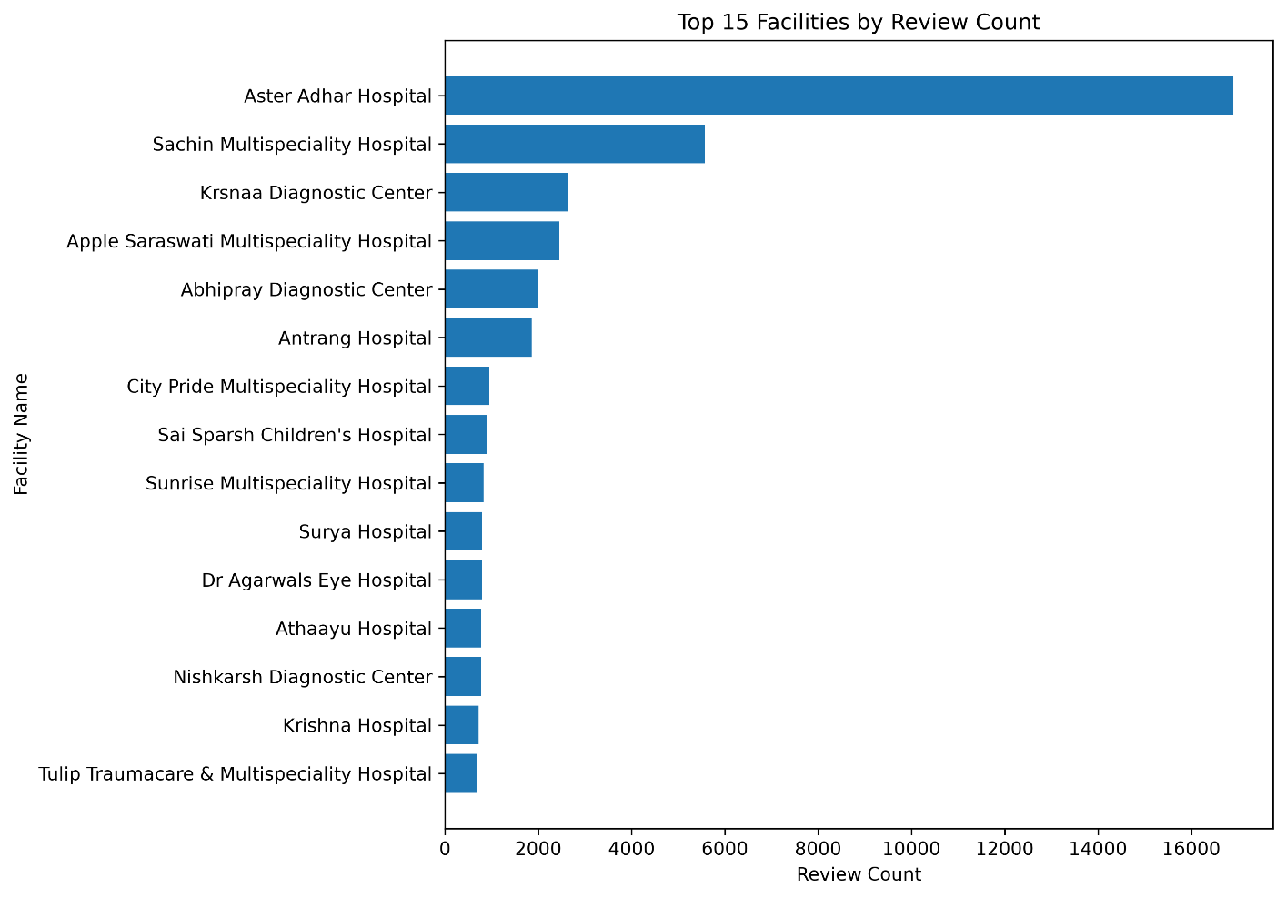
5. Facility Name-wise Count or comparison.
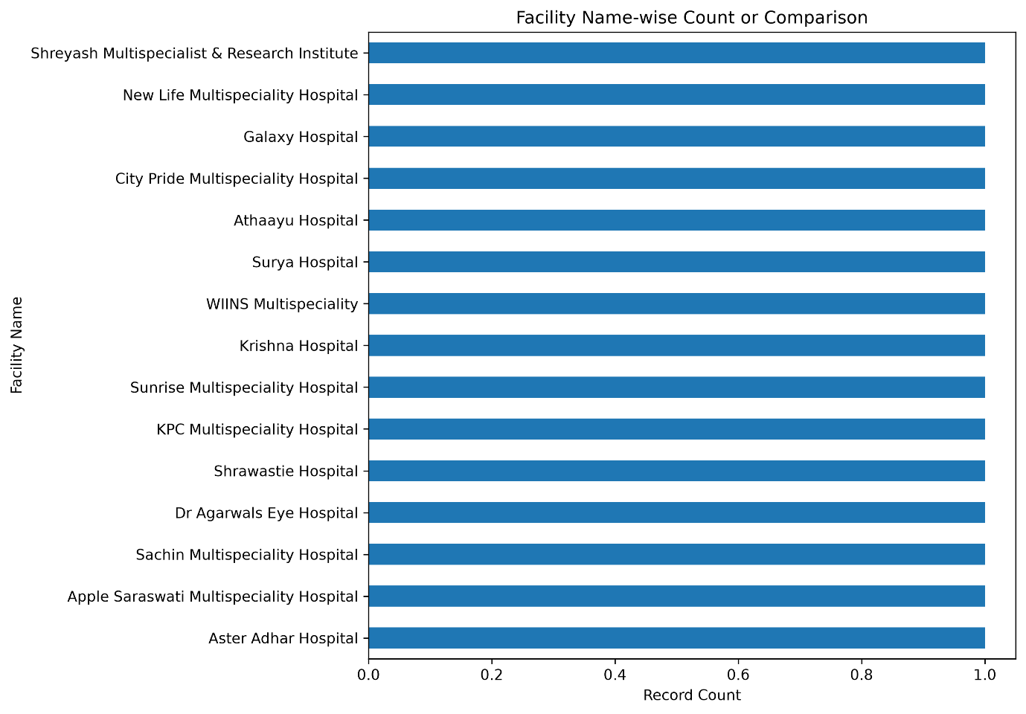

7.Opening Hours Analysis.
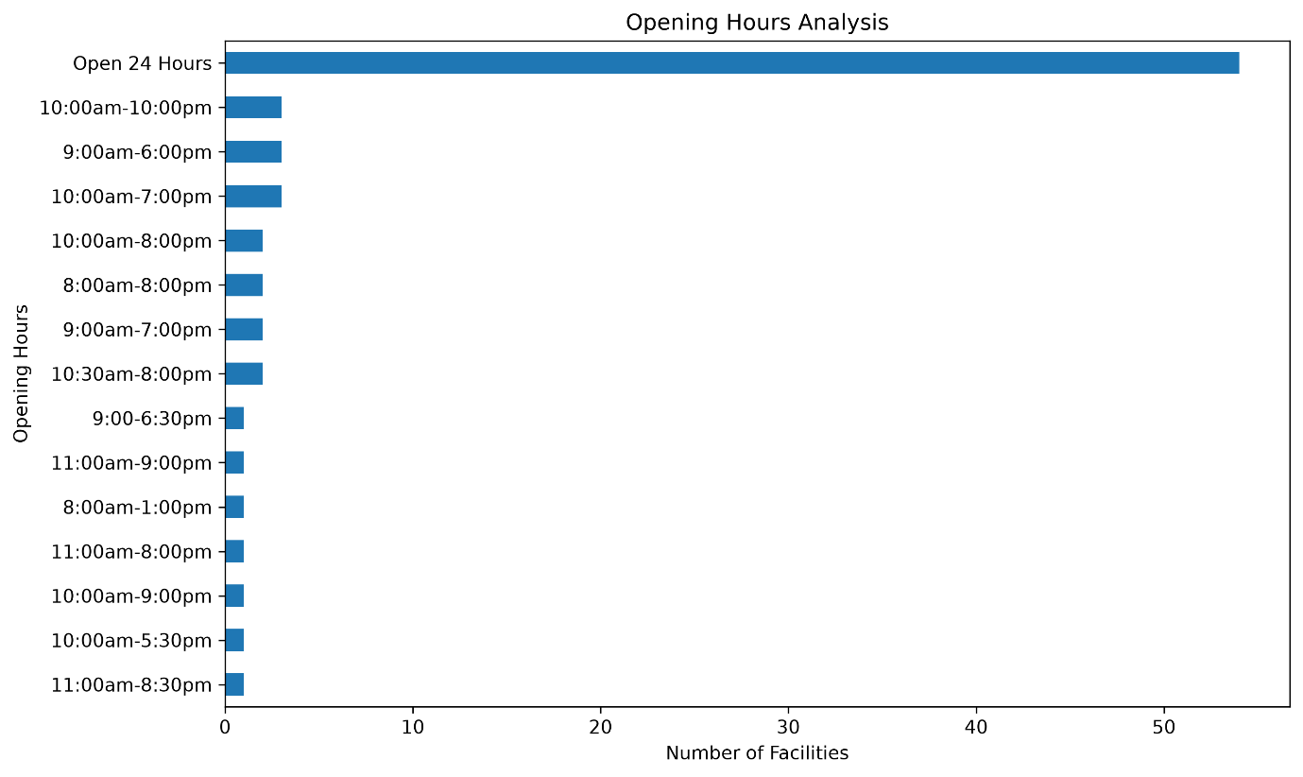

8.Area-wise Average Rating.
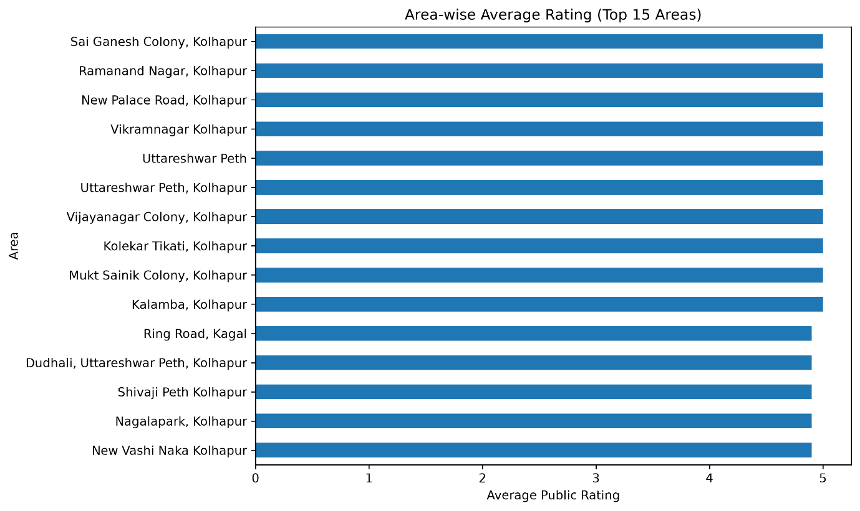

9. Consultation Range Analysis.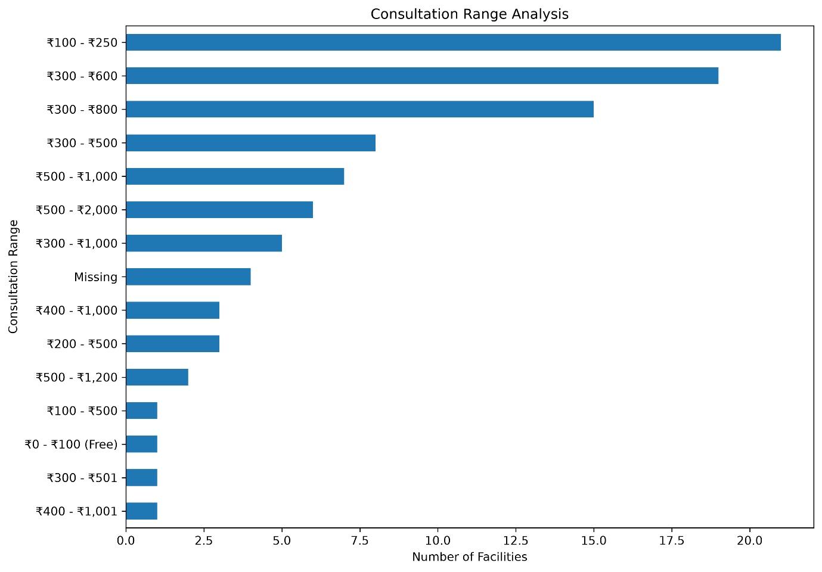

10. Emergency Availability Analysis.
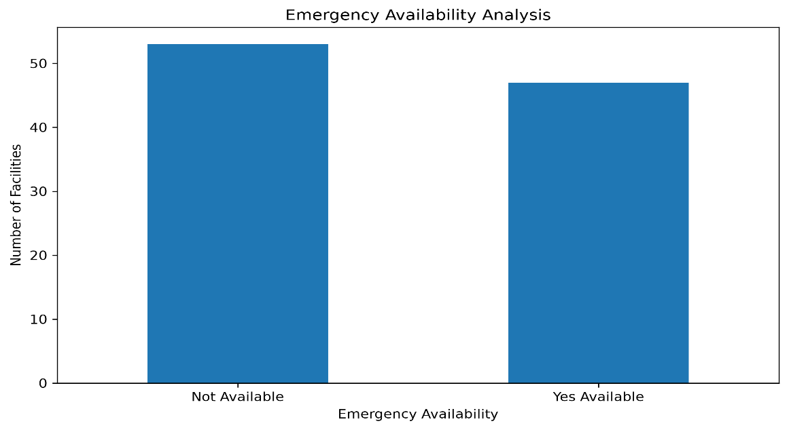

.

Use only the charts that are actually present in the final Python output or Power BI report. Chart titles may differ depending on the final dashboard design.

5.3 KPI Analysis
Useful dashboard KPIs include:
- Total Facilities: 100 collected records.
- Total Hospitals: 50 records.
- Total Clinics: 25 records.
- Total Diagnostic Centers: 25 records.
- Average Public Rating: calculate from valid numeric ratings.
- Emergency Availability: calculate using the actual dataset categories.
These values describe the collected dataset. They do not necessarily describe every facility in the region.

5.4 Power BI Dashboard
Microsoft Power BI was used to build a dashboard from the healthcare dataset. The dashboard combines charts and summaries to help users explore facility types, areas, ratings, opening hours, consultation ranges, and emergency availability.
The dashboard should be checked to ensure that the correct dataset is loaded and that numerical fields use the correct data types and aggregation settings.
Screenshot : Insert a screenshot of the complete Power BI dashboard.
If the report contains multiple dashboard pages, insert a screenshot of each page.
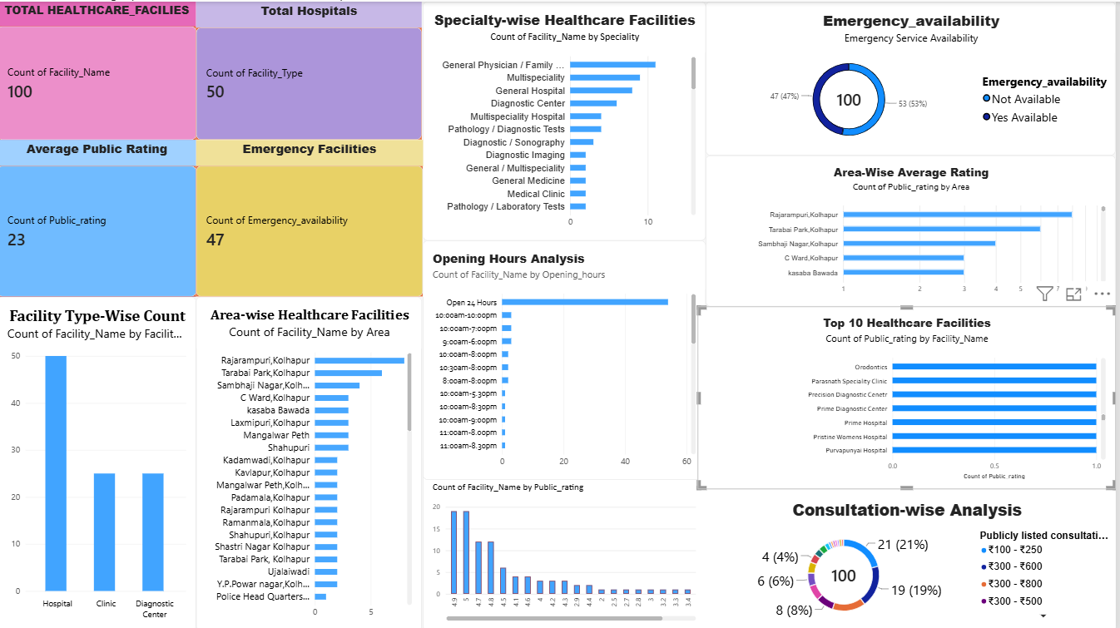

5.5 Visualization Findings
The dashboard allows users to compare the collected facilities by category and area and inspect the available public information.
Specific findings about high or low ratings, areas with fewer facilities, and emergency availability should be written only after checking the actual chart values.

CHAPTER 6: RESULTS AND INSIGHTS

6.1 Analysis Results
The project organized 100 healthcare facility records and used PostgreSQL, Python, and Power BI to analyze and visualize the available information.
The collected dataset contains:
- 50 hospital records.
- 25 clinic records.
- 25 diagnostic center records.
SQL queries were used for database analysis, Python was used for exploratory analysis and charts, and Power BI was used to present the information visually.

6.2 Key Insights
The dataset provides a structured view of the healthcare facilities included in the collection.
The facility-type counts show how the collected records are distributed across hospitals, clinics, and diagnostic centers. Area-wise and rating-wise charts can help identify patterns within these records.
The data can also help identify which public details are unavailable and which facilities require further verification.
Claims about the areas with the fewest facilities, the most available specialties, or the best-rated facilities must be supported by the actual analysis results.

6.3 Business Recommendations for ZoyaSofts
Based on the type of information collected, ZoyaSofts could investigate the following technology opportunities:

- Healthcare Information Dashboard: Develop a dashboard for organizing public facility information.
- Appointment Management System: Explore a system for displaying appointment availability and managing bookings.
- Queue Management: Investigate solutions for managing waiting queues.
- Facility Information Management: Create a process for updating public opening hours, specialties, and service details.
- Emergency Information Verification: Explore ways to maintain and verify publicly listed emergency availability.
These are potential business opportunities for further investigation, not proven market demand. Interviews or authorized, non-personal business feedback would help validate them.

6.4 Conclusion
The Local Healthcare Accessibility Analysis project demonstrates a complete data analytics workflow using Excel/CSV, PostgreSQL, Python, and Power BI.
The project organizes publicly available healthcare information, performs database and exploratory analysis, and presents the collected information through visualizations.
It also highlights the importance of data quality, source verification, privacy protection, and careful interpretation of analytical results.

6.5 Future Scope
The project can be improved by:
- Verifying and updating the collected facility information.
- Documenting the source of each record.
- Expanding the dataset using additional verified public sources.
- Conducting authorized, anonymous business surveys where appropriate.
- Adding dates for future trend analysis.
- Improving the dashboard with validated KPIs and filters.
- Evaluating appointment, queue management, and healthcare information software opportunities.

ANNEXURES

Annexure A: Dataset
Attach the original and/or cleaned CSV file used in the analysis. Ensure that it contains only permitted business/facility information.

Annexure B: SQL Code
Attach the important PostgreSQL queries and their results, including:
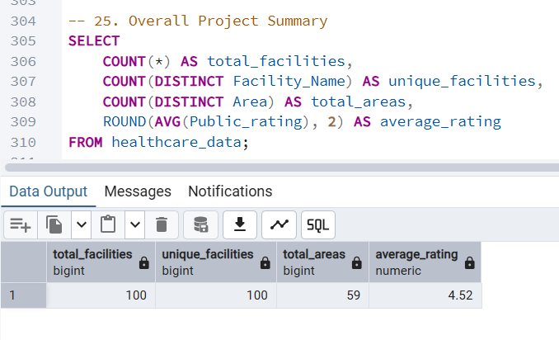

- Total record count.

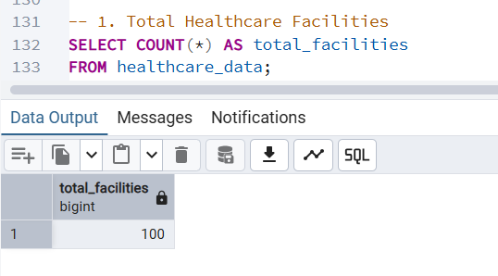
- Facility type-wise count.

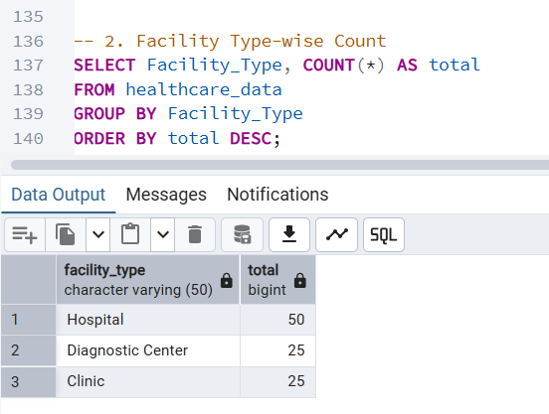

- Area-wise facility count.

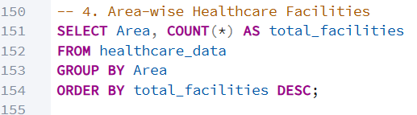

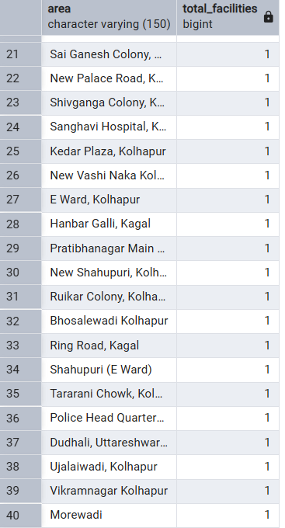
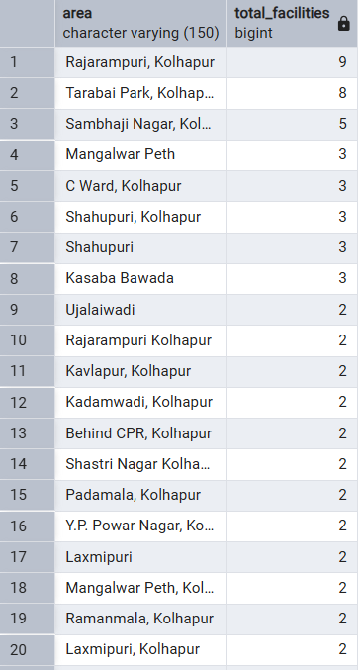

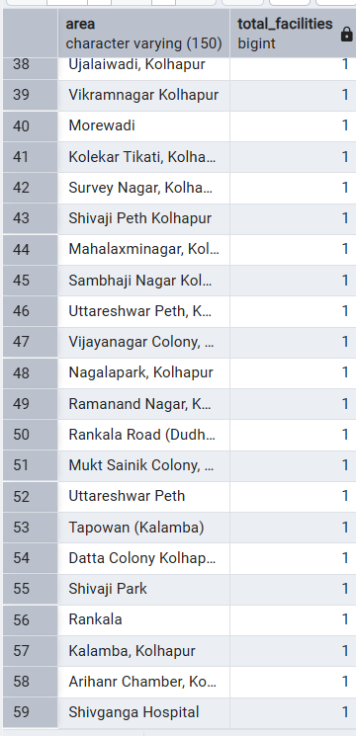

- Public rating analysis.

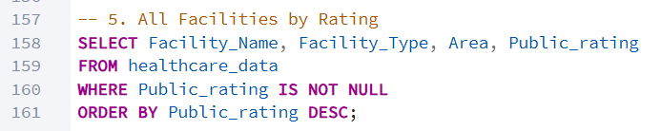
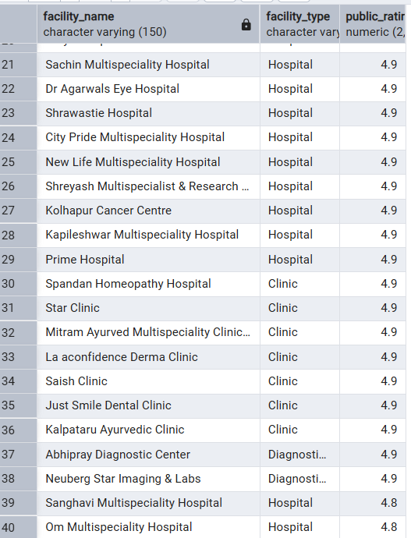
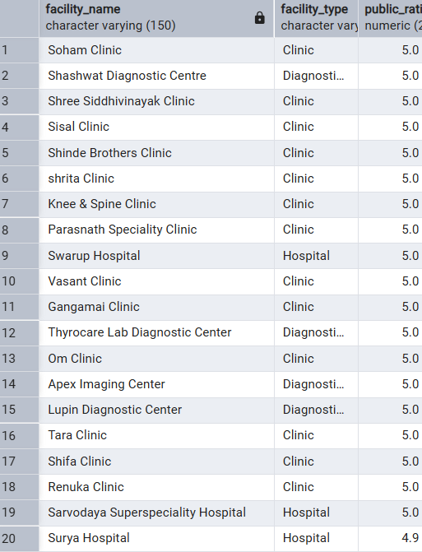

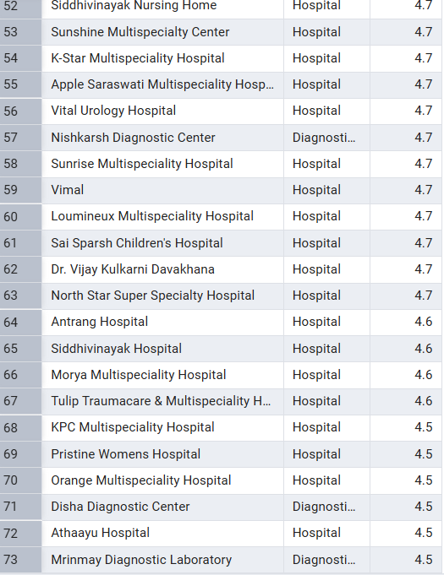
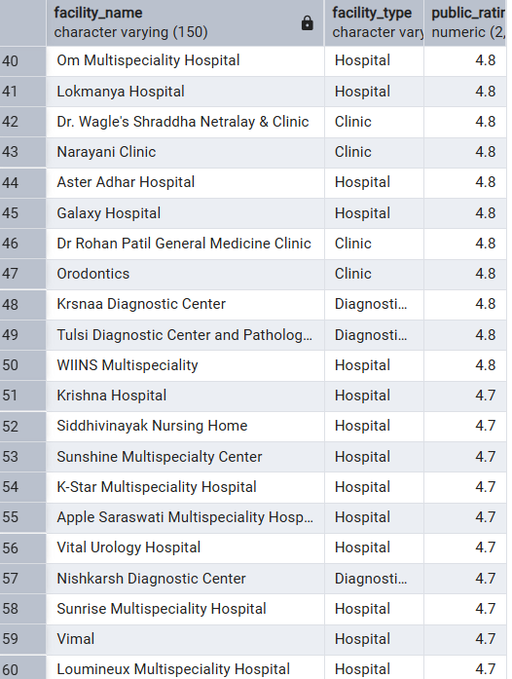

- Review count analysis.

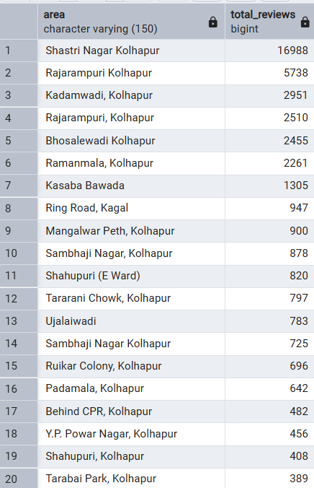
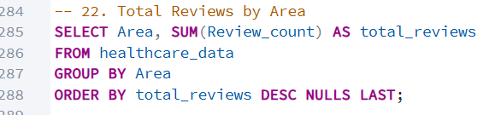
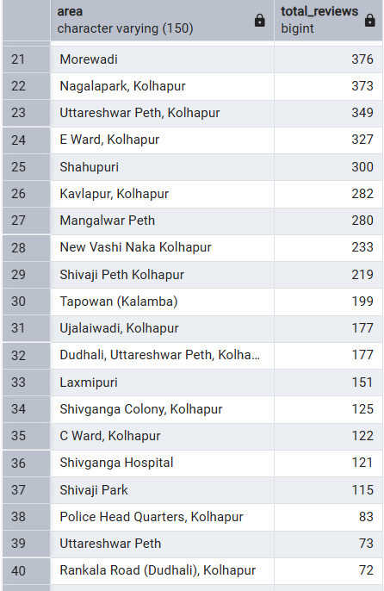

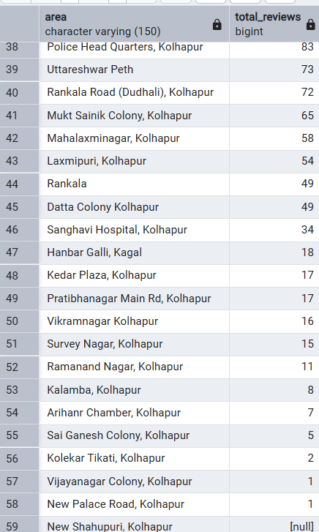

- Emergency availability analysis.
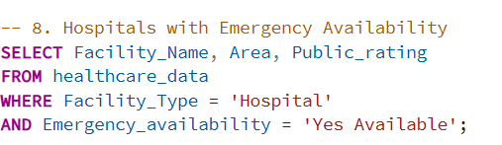

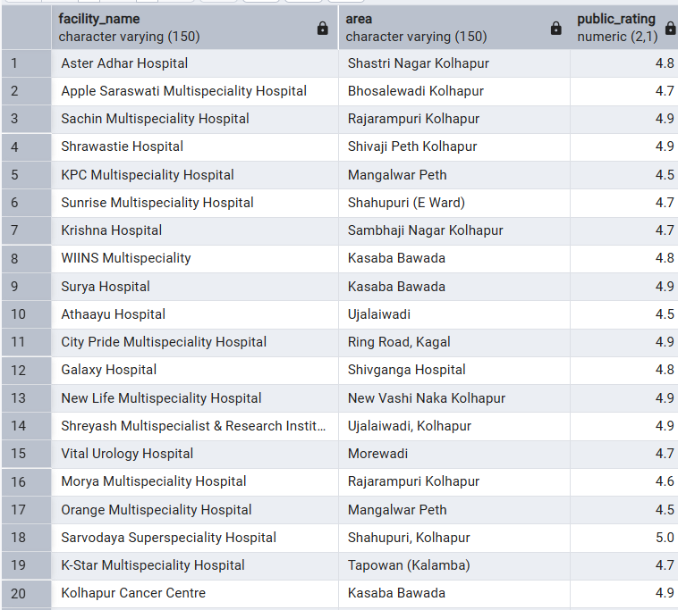

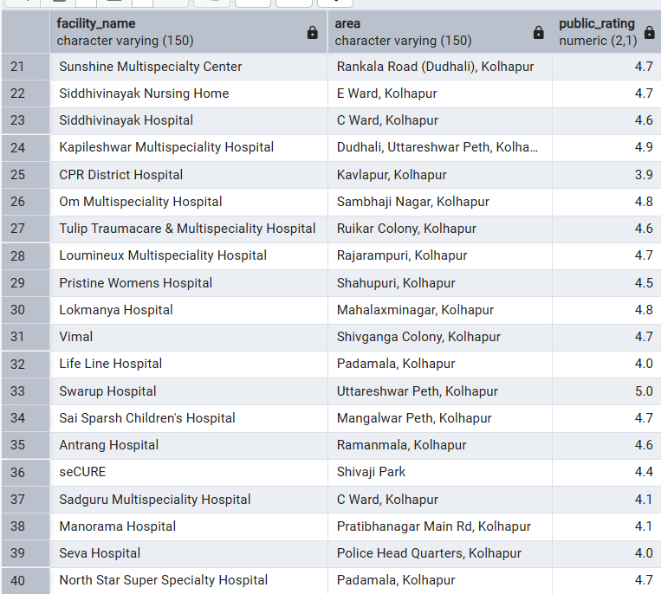

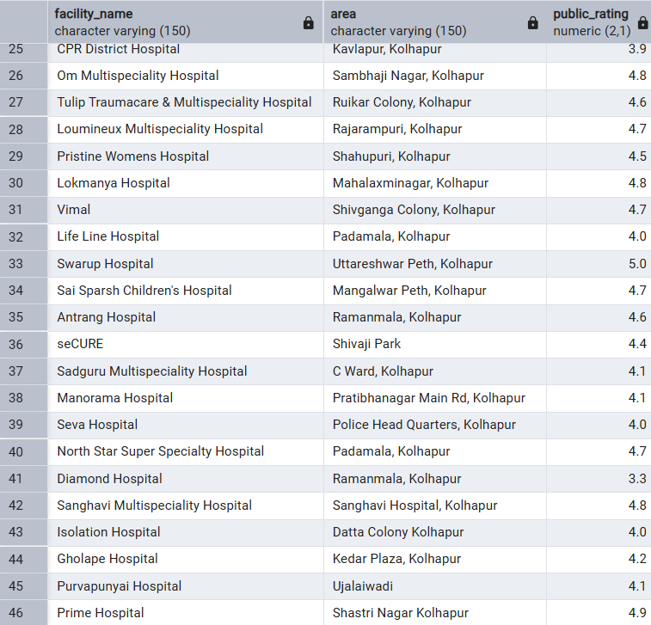

Annexure C: Python Code & Output Screenshots
Attach the Python script used for loading the dataset, inspecting and cleaning data where applicable, performing EDA, and generating charts.
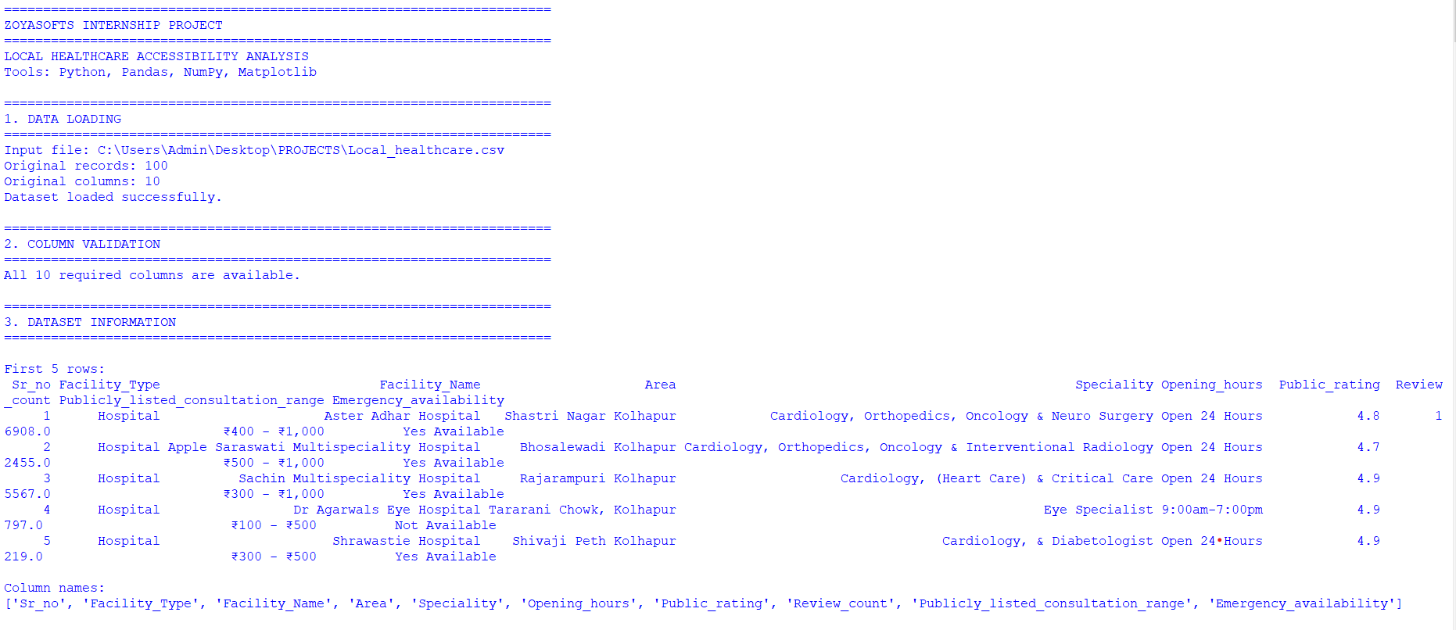
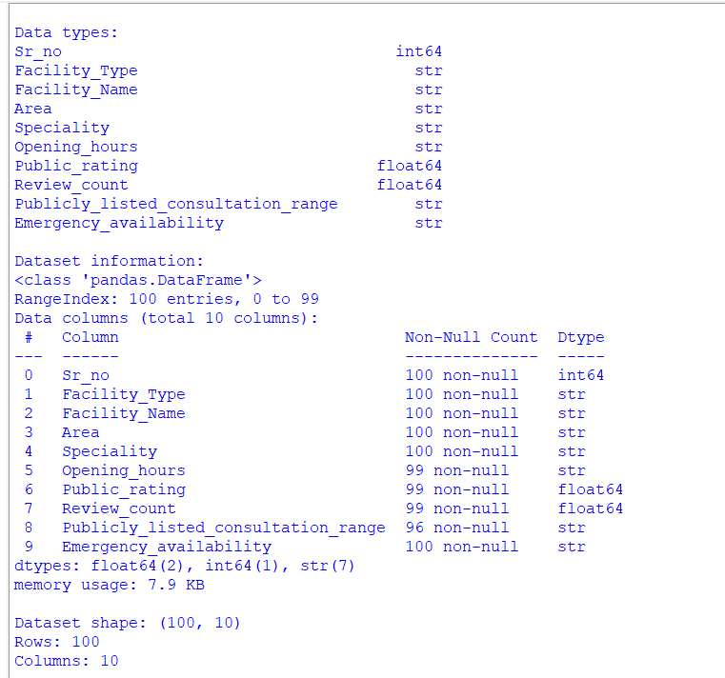
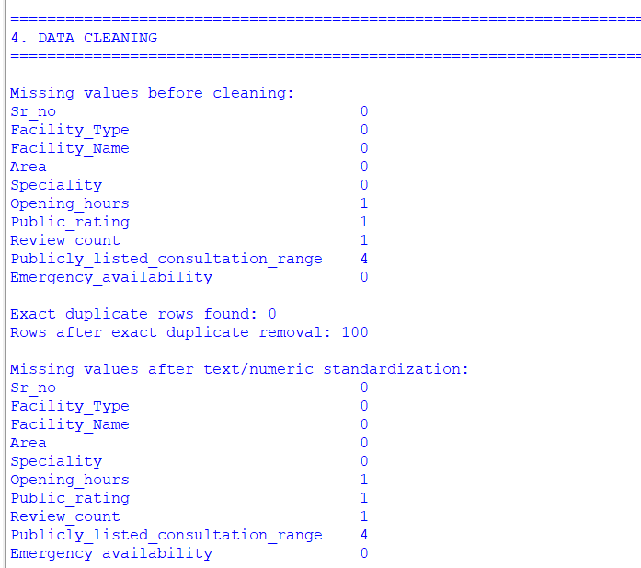
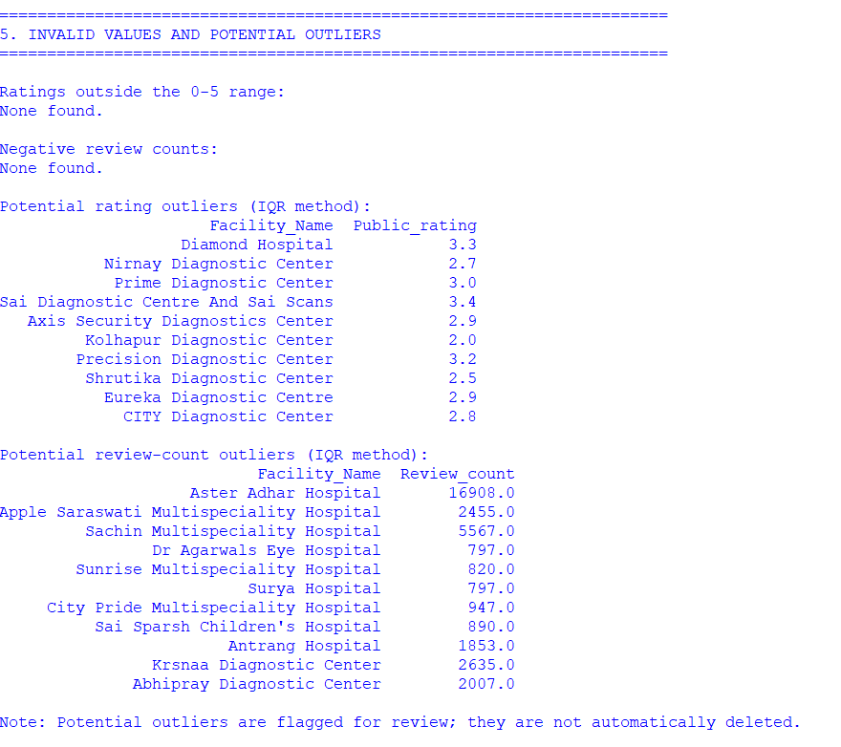
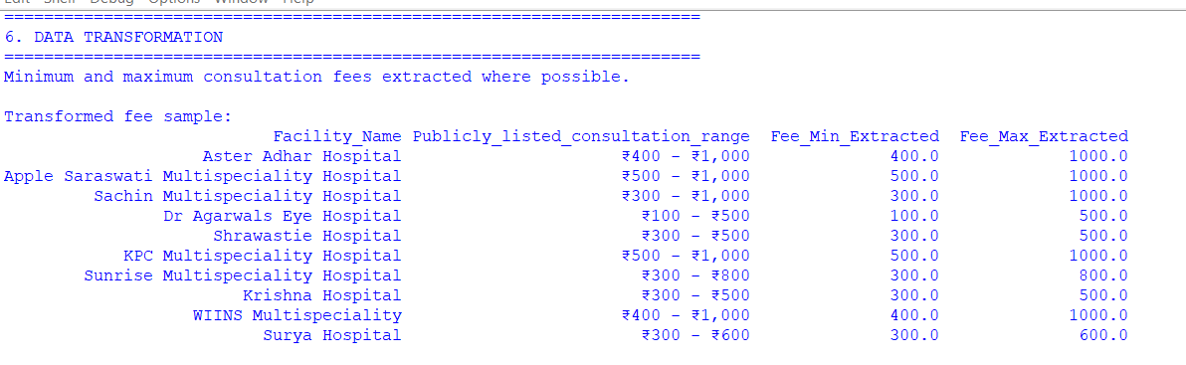
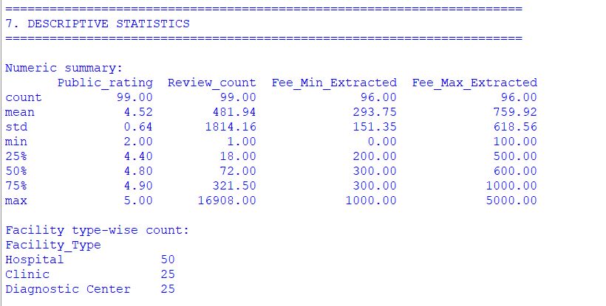
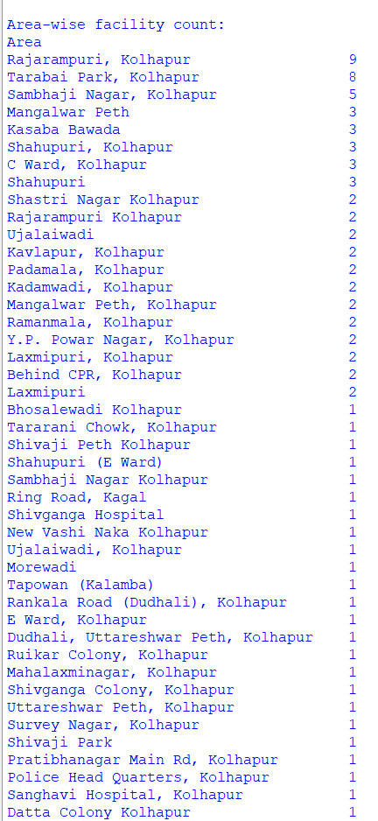
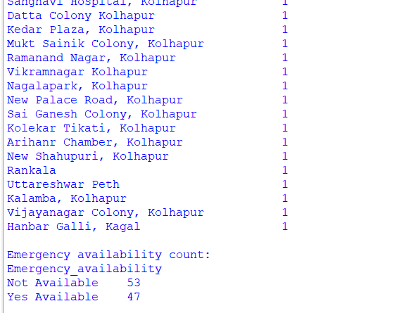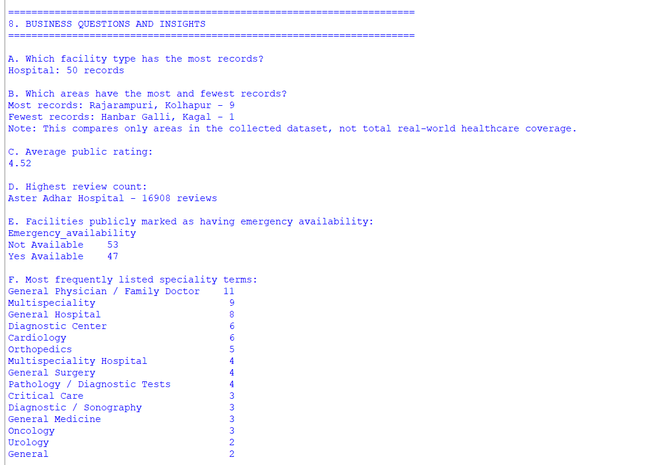
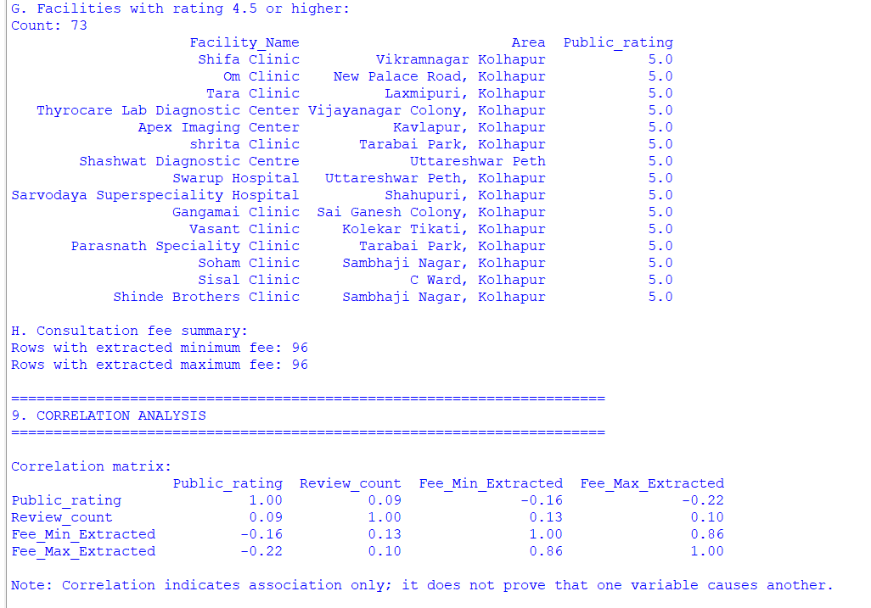
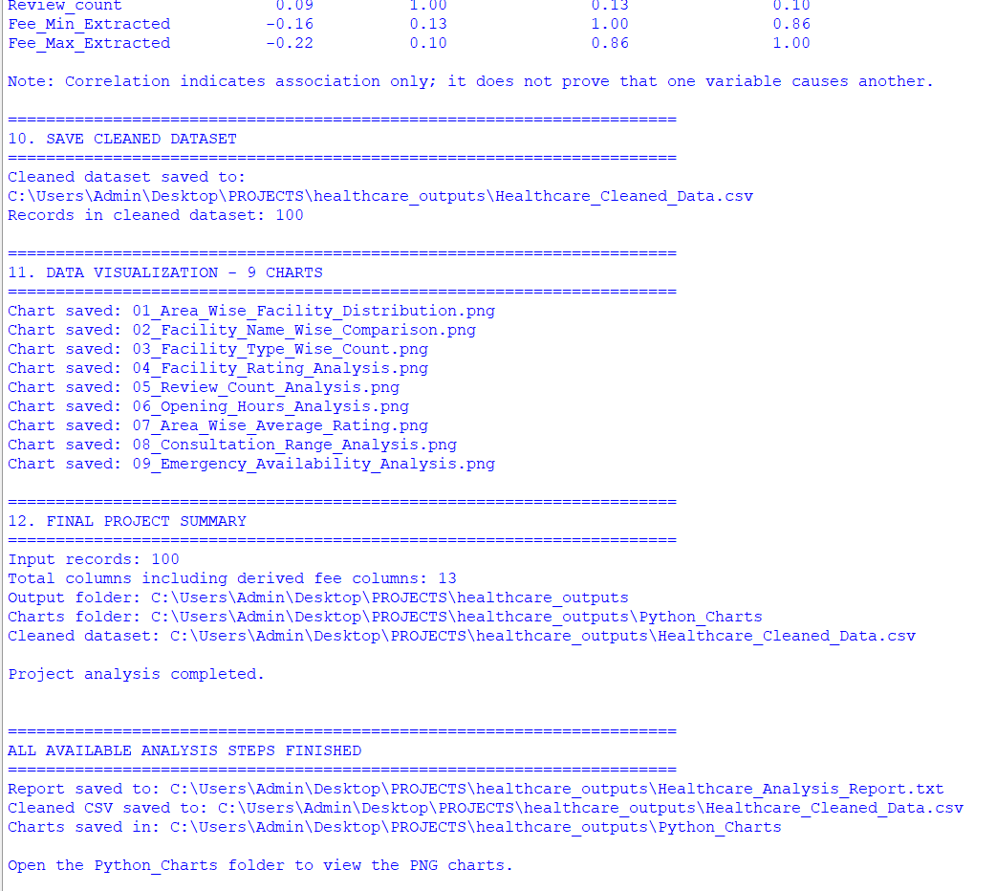

Annexure D: Charts and Graphs
Attach the relevant Python-generated charts.
Table: Summary of Matplotlib Charts
Sr. No. | Chart Name | Graph Type | Purpose
1 | Area-wise Facility Distribution | Horizontal Bar Chart | To compare the number of healthcare facilities across different areas.
2 | Facility Name-wise Comparison | Horizontal Bar Chart | To compare healthcare facilities by name.
3 | Facility Type-wise Count | Bar Chart | To show the number of hospitals, clinics, and diagnostic centers.
4 | Facility Rating Analysis | Histogram | To analyze the distribution of public ratings.
5 | Review Count Analysis | Histogram | To analyze the distribution of public review counts.
6 | Opening Hours Analysis | Horizontal Bar Chart | To compare facilities based on their listed opening hours.
7 | Area-wise Average Rating | Horizontal Bar Chart | To compare average public ratings across different areas.
8 | Consultation Range Analysis | Horizontal Bar Chart | To compare publicly listed consultation fee ranges.
9 | Emergency Availability Analysis | Bar Chart | To show emergency service availability across facilities.

Note: The charts were created using Matplotlib in Python to visualize healthcare facility data and support exploratory data analysis.

Annexure E: Dashboard Screenshots
Attach the completed Power BI dashboard screenshots.

Annexure F: Output Screenshots
Include relevant SQL outputs important analysis results.

Annexure G: References
REFERENCES

The following official documentation and resources were referred to for the development of the project, Local Healthcare Accessibility Analysis.

- Python Documentation. Python Software Foundation. Available at: https://docs.python.org/3/
- Pandas Documentation. Pandas Development Team. Available at: https://pandas.pydata.org/docs/
- NumPy Documentation. NumPy Developers. Available at: https://numpy.org/doc/stable/
- Matplotlib Documentation. Matplotlib Development Team. Available at: https://matplotlib.org/stable/
- Microsoft Power BI Documentation. Microsoft Learn. Available at: https://learn.microsoft.com/en-us/power-bi/
- PostgreSQL Documentation. PostgreSQL Global Development Group. Available at: https://www.postgresql.org/docs/
- Google Maps. Google. Available at: https://maps.google.com/

Project Dataset: Local healthcare facility dataset used for data cleaning, SQL analysis, Python exploratory data analysis, and dashboard preparation.
Note: The original sources for the healthcare facility records should be listed separately after they have been verified.

--------************--------

